WEEK 2 : MONGODB

1. Create a keyspace by name Employee
use Employee
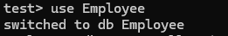
2.
Create a column family by name Employee-Info with attributes Emp_Id Primary
Key, Emp_Name, Designation, Date_of_Joining, Salary, Dept_Name
db.createCollection("Employee_Info")
3.
Insert the values into the table in batch
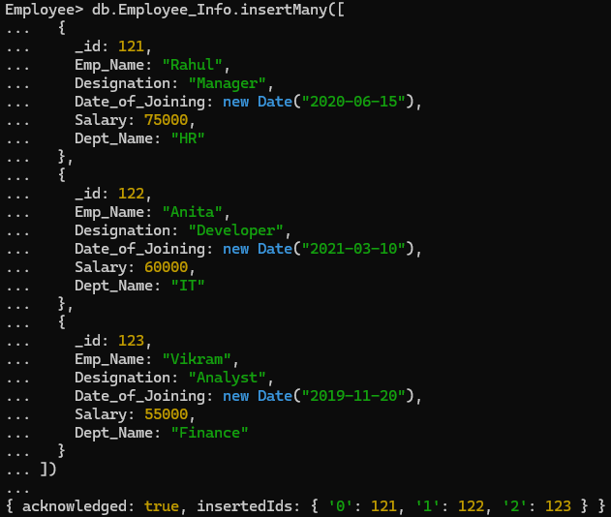
4.
Update Employee name and Department of Emp-Id 121
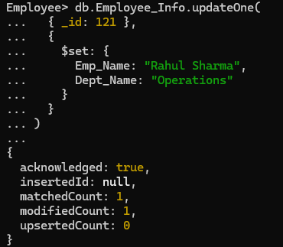
5.
Sort the details of Employee records based on salary
Ascending Order
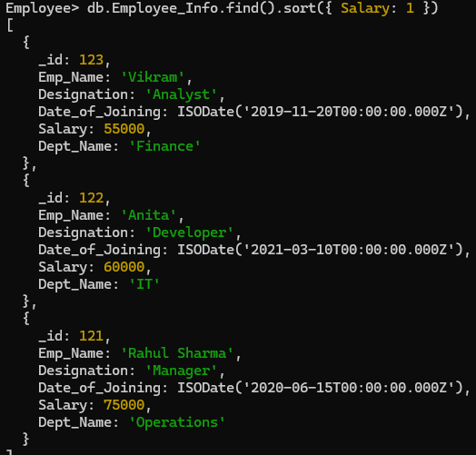

- Descending
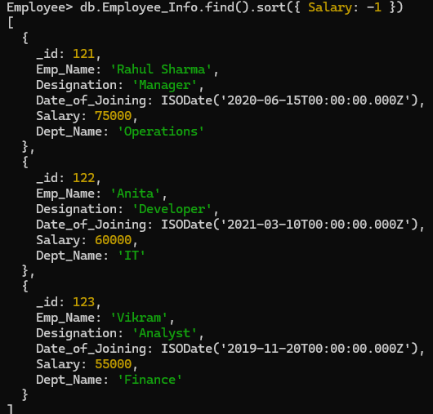
6.
Alter the schema of the table Employee_Info to add a column Projects which
stores a set of Projects done by the corresponding Employee.
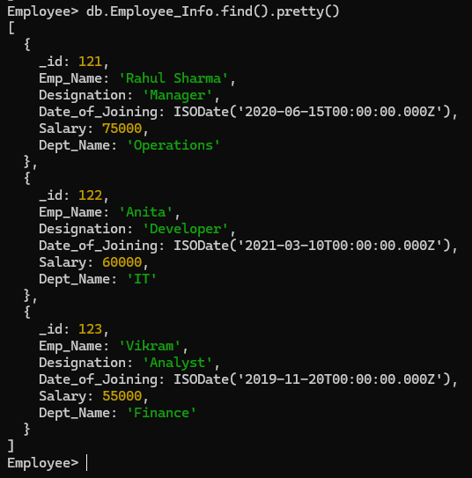
7.
Update the altered table to add project names

